**Year 8 – Humanities and Social Sciences**

**A Significant Individual from the Middle Ages**

Name: _______________________________

Date Due: ________________________

|  |  |  |  |
| --- | --- | --- | --- |
| **Your Target** | **Mark** | **Percentage** | **Weighting (10%)** |
| **Part A: Inquiry Booklet** | **/22** | **/22** |  |  |
| **Part B:**  **Report** | **/20** | **/20** |  |  |

**Part A: Inquiry Process**

Investigate the life of a significant individual in The Middle (Medieval) Ages

Choose one individual from the list provided.

* Use the inquiry booklet to record your information.
* You will have three lessons to conduct your inquiry.
* Lastly, remember to include a bibliography. A range of references must be used.

**Part B: The Report**

Present your findings as a **report**, in four lessons, using your inquiry booklet.

***The report must include***:

* A cover page
* A contents page
* An Introduction
* Headings and sub headings
* Pictures which are **labelled AND REFERRED to**
* The background of the significant individual (family background, early influences)
* The career of the significant individual (key events in their lives, methods used to achieve aims, relationships with other individuals and groups)
* Challenges to the individual presented by others
* Manner and impact of their death
* The legacy of the significant individual (assessment of their life and career, ways they shaped or changed their society, their long-term impact and legacy).
* A conclusion
* A bibliography

1. **Choose a significant individual from the following list:**

* Marco Polo
* Joan of Arc - Genghis Khan
* - Christopher Columbus
* William Walllace – Braveheart - Leif Ericson
* Martin Luther
* King Charlemagne
* Clovis
* Richard the Lionheart - Alfred The Great
* Vlad The Impaler - William The Conqueror
* Justinian

1. **Inquiry Process Booklet**

Which significant individual did you choose for this inquiry?

________________________________________________________

1. **What do you already know about the topic?**

**Background of the individual**- birth, family life, daily routines, food, housing

|  |
| --- |
| **Birth:** |
| **Family life:** |
| **Daily Routines:** |
| **Food:** |
| **Housing:** |
| **Marriage:** |

**Career of the individual**

|  |
| --- |
|  |

**Manner of the individual’s death and its impact on their society**

|  |
| --- |
| **Where and when:** |
| **How:** |
| **Impacts:** |
| **Additional information:** |

**Legacy of the individual: Why is this individual famous or why are they remembered?**

|  |
| --- |
|  |

1. 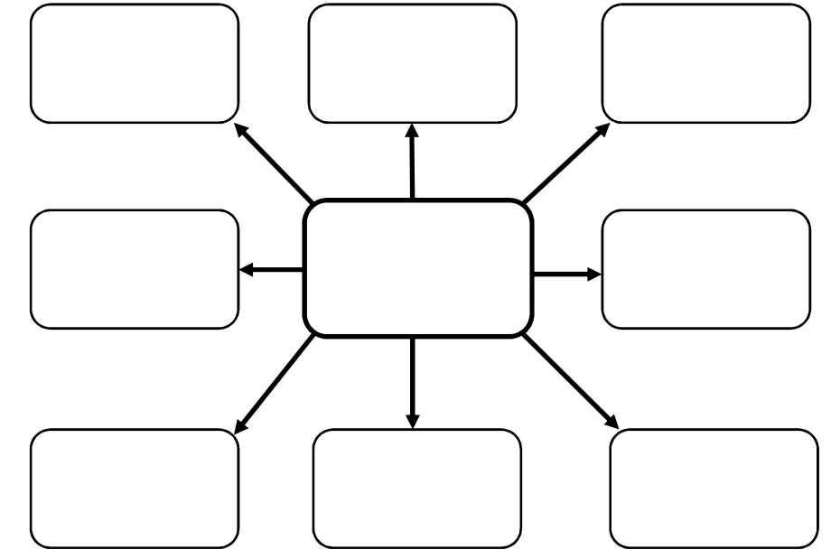**What more do I need to know about the topic?**
2. **Formulate focus questions to help you gather your information.**

|  |
| --- |
|  |
|  |
|  |
|  |
|  |
|  |
|  |
|  |
|  |
|  |
|  |
|  |
|  |
|  |

1. **Note taking sheet**

Focus Question 1

|  |
| --- |
|  |

Key points from information sources and reference details

|  |
| --- |
|  |

Focus Question 2

|  |
| --- |
|  |

Key points from information sources and reference details

|  |
| --- |
|  |

Focus Question 3

|  |
| --- |
|  |

Key points from information sources and reference details

|  |
| --- |
|  |

Focus Question 4

|  |
| --- |
|  |

Key points from information sources and reference details

|  |
| --- |
|  |

Focus Question 5

|  |
| --- |
|  |

Key points from information sources and reference details

|  |
| --- |
|  |